Supplemental Figure 1
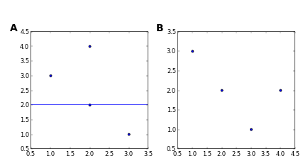
SuppFig1Test. A. This is a test figure 2. B. This is a test figure 1.

Supplemental Figure 2
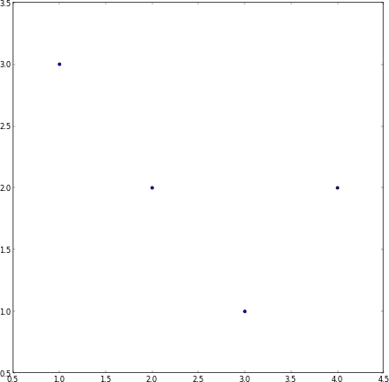
SuppFig2Test. This is a test figure 1.

Supplemental Table 1
X | Y
1 | 4
2 | 3
3 | 2
4 | 1
Testing tables.

